**GARDEN AUTOMATION SYSTEM USING ARDUINO**

BY RED EYES

[redeyes.abs@gmail.com](mailto:redeyes.abs@gmail.com)

**v1.0**

**Introduction**

20th century is growing fast like ‘a room sized computer reduced into small sized smart phones’. People converted all human works into machine works to achieve maximum productivity in minimum time. Now days, the machine works integrated with automation along with artificial intelligence to bring more quality in each product.

Garden automation is a simple automation project that will manage water, food or anything that to be managed in a particular time. It consists 3 modules

1. Controller
2. Connector
3. Garden

Controller module consists a controller named ‘Arduino’ that will act like a brain of our project. Arduino is connected with RTC(Real time clock) that will maintain the current time and a solenoid valve that will do open/close task in a fixed time that we set by default. Then through connector module water will flow on time to the garden. So our garden will be always moisturized and clean.

So through automation it helps to achieve our goal that ‘something making happened without a human hand’ besides it helps to gain some income if we are ready to implement it in advanced way.

**Components**

* Arduino Uno(Controller)
* RTC DS1307(Real time clock)
* Solinoid valve(12v)DC
* Switch circuit(To switch solenoid valve from arduino)
* 12v dc adapter(Power supply)
* **Arduino-IDE(Software)**

**Features**

* Water will flow every day in proper time
* No need of human hand
* It will not effect our daily works
* Less cost and maintenance
* Consumes very low Power

Circuit used

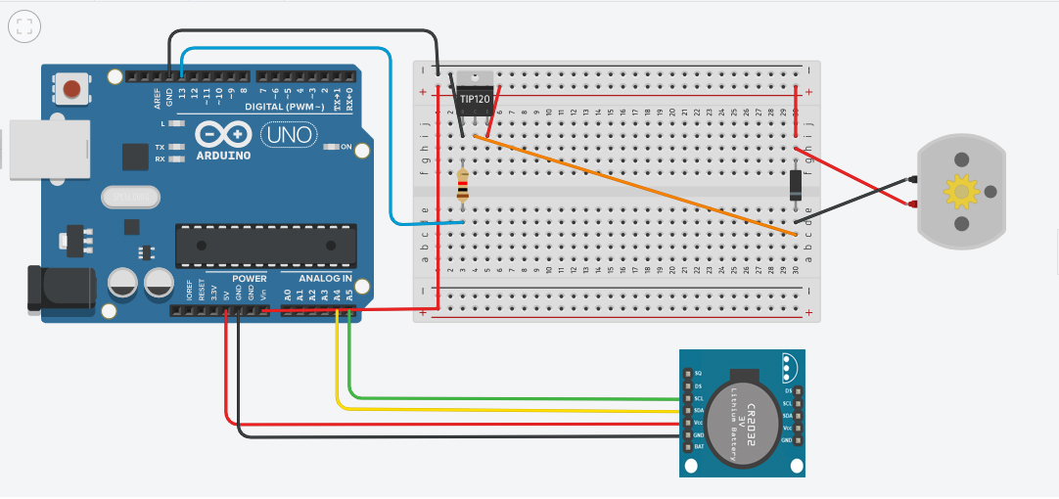

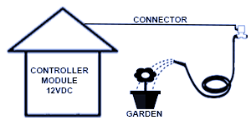

**ScreesnShots**



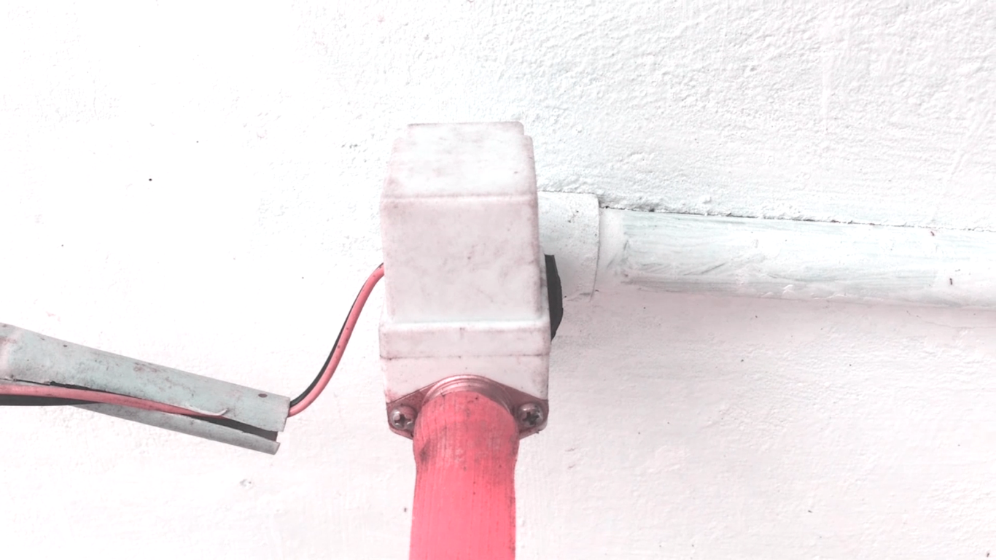







**=**

**Future Implemetations**

1. **Automatic pet feeding system**
2. **Digital Calendar**
3. **Eva -the ro**

**Code**

// Date and time functions using a DS1307 RTC connected via I2C and Wire lib

#include <Wire.h>

#include "RTClib.h"

RTC_DS1307 rtc;

int pin=13;

void setup () {

pinMode(pin, OUTPUT);

// Wire.begin();

Serial.begin(9600);

if (! rtc.begin()) {

Serial.println("Couldn't find RTC");

while (true);

}

// rtc.adjust(DateTime(F(__DATE__), F(__TIME__)));

//rtc.adjust(DateTime(2019,4,28,3,0,0));

}

void loop () {

DateTime now = rtc.now();

Serial.println("Year: ");

Serial.println(now.hour(),DEC);

Serial.println(now.minute(),DEC);

//MORNING

if(now.hour() == 06 && now.minute() == 30 && now.second() == 00){

Serial.println("morning>....................<<>>..........");

digitalWrite(pin, HIGH); // turn the LED on (HIGH is the voltage level)

delay(30000); // wait for a second

digitalWrite(pin, LOW); // turn the LED off by making the voltage LOW

delay(30000);

// waits 15ms for the servo to reach the position

}

//EVENING

else if(now.hour() == 16 && now.minute() == 58 && now.second() == 00){

Serial.println("evening>....................<<>>..........");

digitalWrite(pin, HIGH); // turn the LED on (HIGH is the voltage level)

delay(30000); // wait for a second

digitalWrite(pin, LOW); // turn the LED off by making the voltage LOW

delay(30000);

// waits 15ms for the servo to reach the position

}

}

**References**

**Arduino.forum**

**Instructables**

**bc-robotics.com**

**THANK YOU**